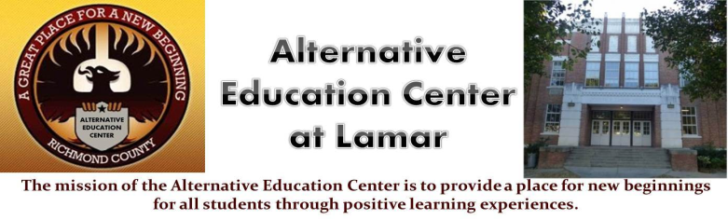**Alternative Education Center**

**Charles Givens- Principal**

Chauncey Scott – Asst. Principal

Work Phone -706-796-4965 970 Baker Ave. Augusta, GA 30904

­­­­­­­­­­­­­­­­­­­­­­­­­------------------------------------------------------------------------------------------------------------------------------------------------------------------------------------------------------------------------------------------------------------------------------------------------------------------------------------------------------------------------------------------------------------------------------------------------

Parent Information

All Parents will be instructed on the Title 1 Parent Policy, Parent –School Compact, the Survey and School Wide Plan upon intake of each student.

Please attend all Parent Meetings and visit and use the Parent Resource Room for information and Resources.

Thank You